Assignment – 8
Task – 1
Description:
Use AI to generate test cases for is_valid_email(email) and then implement the validator function.
Requirements:
• Must contain @ and . characters.
• Must not start or end with special characters.
• Should not allow multiple @.
Prompt:
Generate test cases for is_valid_email(email) and implement the function. The email must contain @ and ., must not start or end with special characters, and should not allow multiple @.
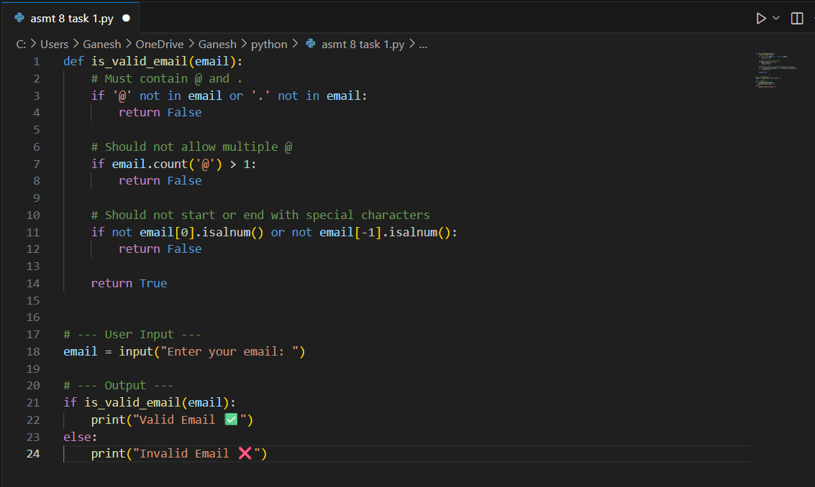

Expected Output: Email validation logic passing all test cases
Practical output:
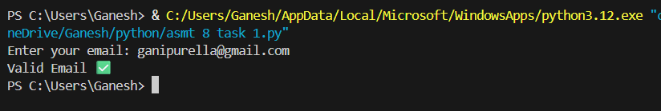
Task – 2
Description:
Ask AI to generate test cases for assign_grade(score) function. Handle boundary and invalid inputs
Requirements
- AI should generate test cases for assign_grade(score) where: 90-100: A, 80-89: B, 70-79: C, 60- 69: D, <60: F
- Include boundary values and invalid inputs (e.g., -5, 105, "eighty").
Prompt:
Write a Python program to take user input for score and assign grade (A–F). Handle invalid inputs and show test cases

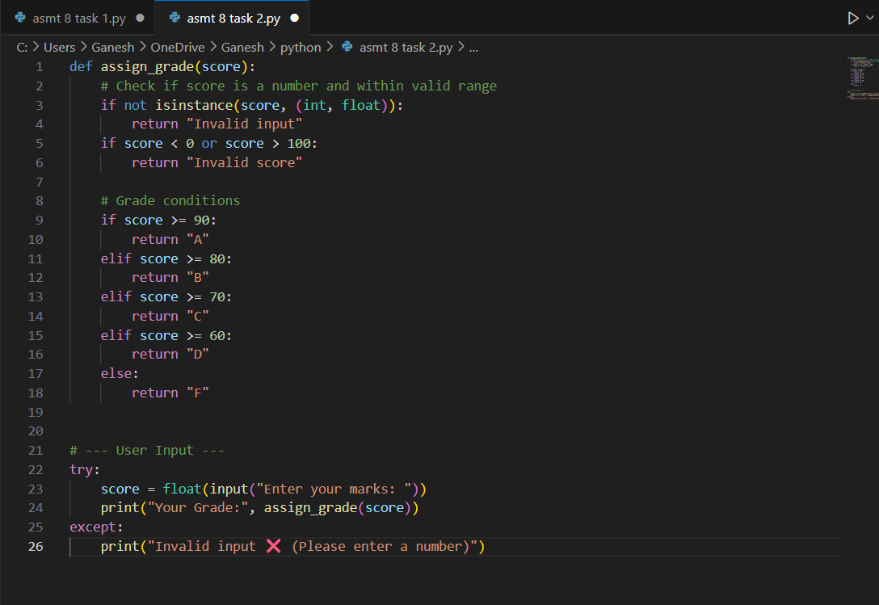

Expected Output: Grade assignment function passing test suite
Practical output:
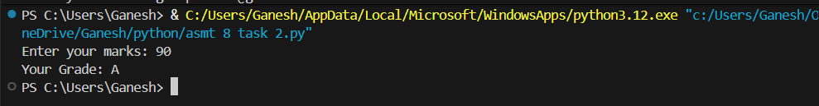
Task – 3
Description:
Generate test cases using AI for is_sentence_palindrome(sentence). Ignore case, punctuation, and spaces
Requirement:
• Ask AI to create test cases for is_sentence_palindrome(sentence) (ignores case, spaces, and punctuation).
• Example: "A man a plan a canal Panama" → True
Prompt:
Write a Python program to check if a sentence is a palindrome, ignoring case, spaces, and punctuation.

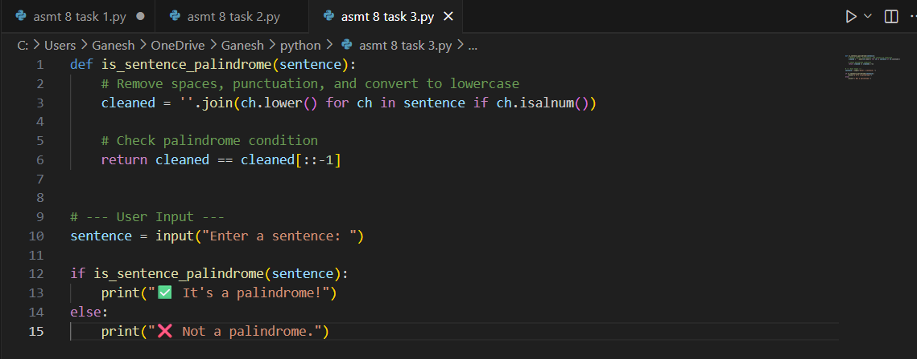
Expected Output: Function returns True/False for cleaned sentences
Implement the function to pass AI-generated tests
Practical output:
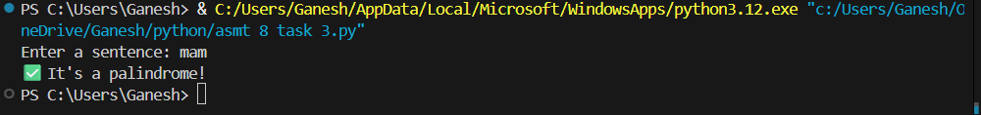
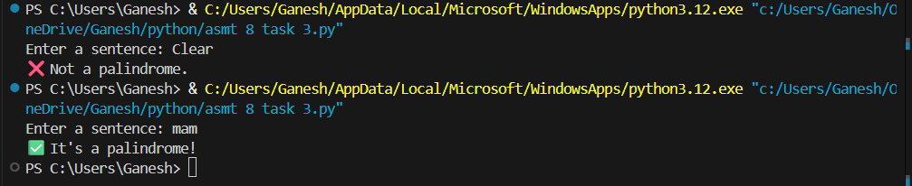
Task – 4
Description:
Let AI fix it Prompt AI to generate test cases for a ShoppingCart class (add_item, remove_item, total_cost).
Methods:
Add_item(name,orice) Remove_item(name) Total_cost()
Prompt:
Write a Python program for a ShoppingCart class with methods add_item(name, price), remove_item(name), and total_cost()

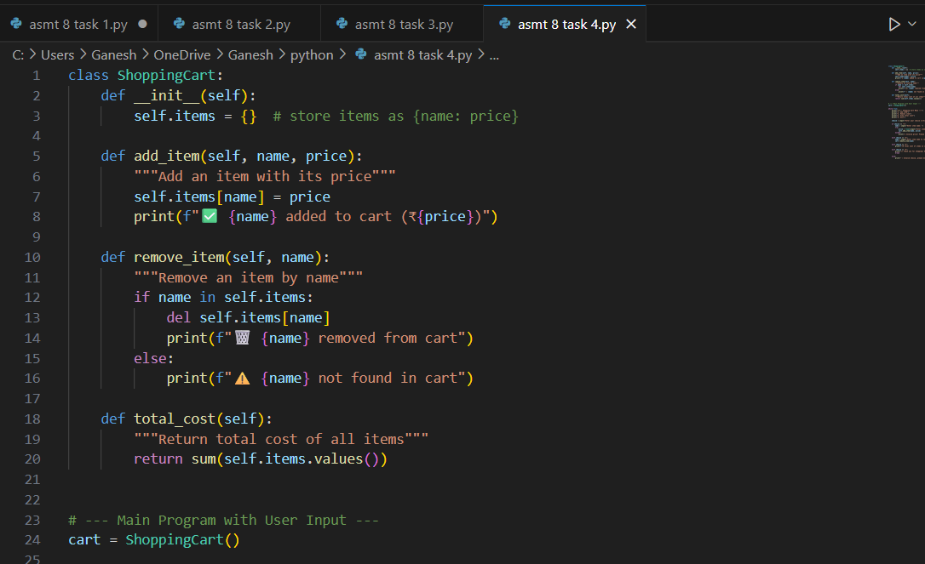
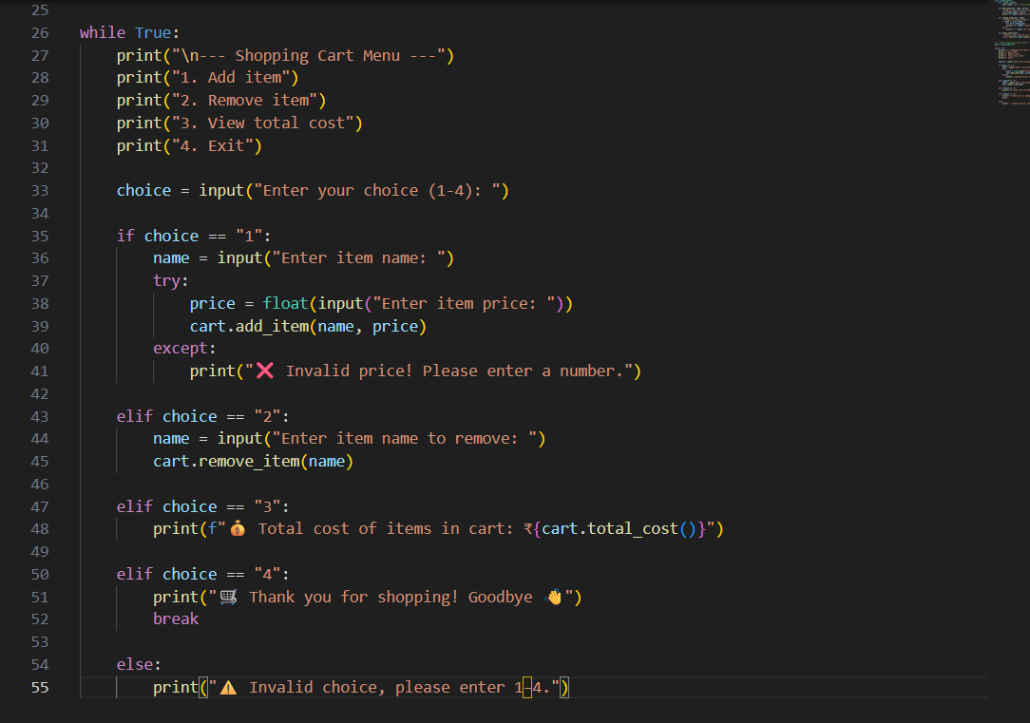
Expected Output: Full class with tested functionalities
Practical output:
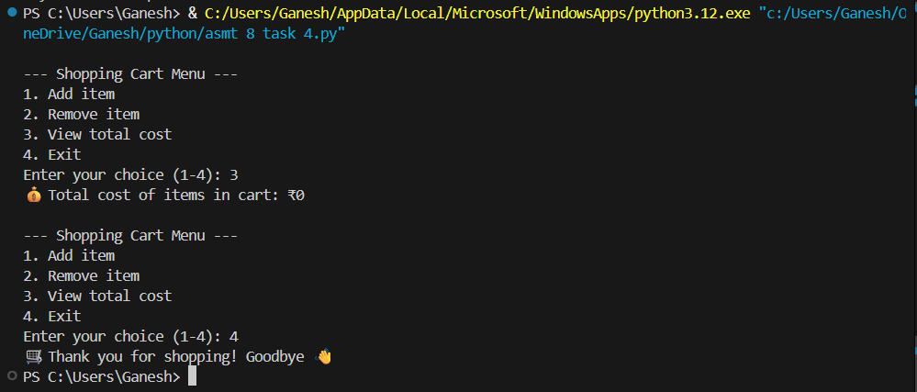

Task – 5
Description:
Use AI to write test cases for convert_date_format(date_str) to switch from "YYYY-MM-DD" to "DD-MM-YYYY".
Example: "2023-10-15" → "15-10-2023"
PROMPT:
Write a Python program to convert date from "YYYY-MM-DD" to "DD-MM-YYYY"
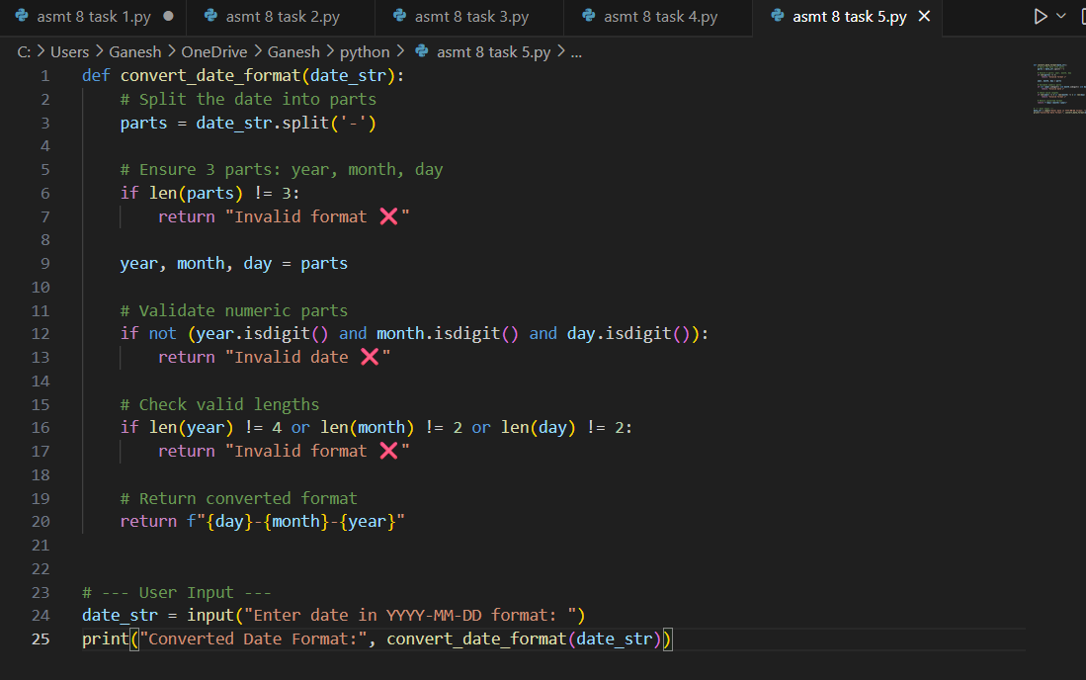
Expected Output: Function converts input format correctly for all test cases
Practical output:
